Additional file
A.1 Simulation scenarios
Table A.1 List of all evaluated scenarios
Scen. | Nclus | Nclus type | Cluster_size  (S,L or S, M, L) | CV | ICC | Power from SWSamp | Number of unique allocations | Weighted expected power | Loss of power
1 | 12 | 9,3 | 75.16, 160.51 | 0.4 | 0.01 | 0.8002 | 20 | 0.7996 | 0.0006
2 | 12 | 9,3 | 91.91, 196.27 | 0.4 | 0.05 | 0.7997 | 20 | 0.8029 | -0.0033
3 | 12 | 9,3 | 96.19, 205.42 | 0.4 | 0.1 | 0.8003 | 20 | 0.7947 | 0.0055
4 | 12 | 6,6 | 59.54, 133.46 | 0.4 | 0.01 | 0.8002 | 44 | 0.7998 | 0.0004
5 | 12 | 6,6 | 72.81, 163.19 | 0.4 | 0.05 | 0.7997 | 44 | 0.7999 | -0.0002
6 | 12 | 6,6 | 76.2, 170.8 | 0.4 | 0.1 | 0.8003 | 44 | 0.7994 | 0.0008
7 | 12 | 9,3 | 59.16, 208.52 | 0.7 | 0.01 | 0.8002 | 20 | 0.7954 | 0.0048
8 | 12 | 9,3 | 72.34, 254.98 | 0.7 | 0.05 | 0.7997 | 20 | 0.7994 | 0.0004
9 | 12 | 9,3 | 75.71, 266.86 | 0.7 | 0.1 | 0.8002 | 20 | 0.804 | -0.0038
10 | 12 | 6,6 | 31.83, 161.17 | 0.7 | 0.01 | 0.8002 | 44 | 0.7874 | 0.0128
11 | 12 | 6,6 | 38.92, 197.08 | 0.7 | 0.05 | 0.7997 | 44 | 0.7956 | 0.0041
12 | 12 | 6,6 | 40.73, 206.27 | 0.7 | 0.1 | 0.8003 | 44 | 0.7955 | 0.0048
13 | 12 | 9,3 | 43.16, 256.53 | 1 | 0.01 | 0.8002 | 20 | 0.7821 | 0.0181
14 | 12 | 9,3 | 52.77, 313.68 | 1 | 0.05 | 0.7997 | 20 | 0.7946 | 0.0051
15 | 12 | 9,3 | 55.23, 328.3 | 1 | 0.1 | 0.8003 | 20 | 0.7895 | 0.0108
16 | 12 | 9,3 | 27.15, 304.54 | 1.3 | 0.01 | 0.8002 | 20 | 0.7657 | 0.0345
17 | 12 | 9,3 | 33.2, 372.39 | 1.3 | 0.05 | 0.7997 | 20 | 0.7897 | 0.0100
18 | 12 | 9,3 | 34.75, 389.74 | 1.3 | 0.1 | 0.8003 | 20 | 0.792 | 0.0083
19 | 12 | 6,4,2 | 66.16, 105.75, 169.04 | 0.4 | 0.01 | 0.8002 | 238 | 0.7947 | 0.0055
20 | 12 | 6,4,2 | 80.9, 129.31, 206.7 | 0.4 | 0.05 | 0.7997 | 238 | 0.8009 | -0.0012
21 | 12 | 6,4,2 | 84.67, 135.34, 216.33 | 0.4 | 0.1 | 0.8003 | 238 | 0.7999 | 0.0003
22 | 12 | 4,4,4 | 55.19, 89.42, 144.88 | 0.4 | 0.01 | 0.8002 | 415 | 0.7955 | 0.0047
23 | 12 | 4,4,4 | 67.49, 109.35, 177.16 | 0.4 | 0.05 | 0.7997 | 415 | 0.7976 | 0.0021
24 | 12 | 4,4,4 | 70.64, 114.44, 185.42 | 0.4 | 0.1 | 0.8003 | 415 | 0.7991 | 0.0012
25 | 12 | 6,4,2 | 47.16, 104.03, 229.47 | 0.7 | 0.01 | 0.8002 | 238 | 0.7915 | 0.0088
26 | 12 | 6,4,2 | 57.67, 127.2, 280.59 | 0.7 | 0.05 | 0.7997 | 238 | 0.7938 | 0.0059
27 | 12 | 6,4,2 | 60.36, 133.13, 293.67 | 0.7 | 0.1 | 0.8003 | 238 | 0.7962 | 0.0040
28 | 12 | 4,4,4 | 30.38, 74.83, 184.29 | 0.7 | 0.01 | 0.8003 | 415 | 0.7891 | 0.0112
29 | 12 | 4,4,4 | 37.15, 91.5, 225.35 | 0.7 | 0.05 | 0.7997 | 415 | 0.7996 | 0.0001
30 | 12 | 4,4,4 | 38.88, 95.76, 235.85 | 0.7 | 0.1 | 0.8003 | 415 | 0.7901 | 0.0101
31 | 12 | 6,4,2 | 31.45, 95.95, 292.77 | 1 | 0.01 | 0.8002 | 238 | 0.7799 | 0.0203
32 | 12 | 6,4,2 | 38.45, 117.33, 357.99 | 1 | 0.05 | 0.7997 | 238 | 0.7951 | 0.0046
33 | 12 | 6,4,2 | 40.24, 122.79, 374.68 | 1 | 0.1 | 0.8003 | 238 | 0.7915 | 0.0087
34 | 12 | 6,4,2 | 18.96, 82.32, 357.49 | 1.3 | 0.01 | 0.8002 | 238 | 0.7694 | 0.0308
35 | 12 | 6,4,2 | 23.18, 100.66, 437.14 | 1.3 | 0.05 | 0.7997 | 238 | 0.7868 | 0.0129
36 | 12 | 6,4,2 | 24.26, 105.35, 457.51 | 1.3 | 0.1 | 0.8002 | 238 | 0.7915 | 0.0087
37 | 24 | 18,6 | 34.44, 74.68 | 0.4 | 0.01 | 0.8029 | 84 | 0.7981 | 0.0048
38 | 24 | 18,6 | 42.57, 92.3 | 0.4 | 0.05 | 0.7994 | 84 | 0.795 | 0.0044
39 | 24 | 18,6 | 46.44, 100.69 | 0.4 | 0.1 | 0.8044 | 84 | 0.7995 | 0.0049
40 | 24 | 12,12 | 27.07, 61.93 | 0.4 | 0.01 | 0.8028 | 231 | 0.8043 | -0.0015
41 | 24 | 12,12 | 33.46, 76.54 | 0.4 | 0.05 | 0.7995 | 231 | 0.794 | 0.0054
42 | 24 | 12,12 | 36.51, 83.49 | 0.4 | 0.1 | 0.8043 | 231 | 0.7981 | 0.0062
43 | 24 | 18,6 | 26.89, 97.32 | 0.7 | 0.01 | 0.8028 | 84 | 0.7897 | 0.0131
44 | 24 | 18,6 | 33.24, 120.28 | 0.7 | 0.05 | 0.7995 | 84 | 0.7888 | 0.0107
45 | 24 | 18,6 | 36.26, 131.21 | 0.7 | 0.1 | 0.8042 | 84 | 0.7991 | 0.0052
46 | 24 | 12,12 | 14.01, 74.99 | 0.7 | 0.01 | 0.8028 | 231 | 0.7888 | 0.0140
47 | 24 | 12,12 | 17.31, 92.69 | 0.7 | 0.05 | 0.7995 | 231 | 0.7907 | 0.0088
48 | 24 | 12,12 | 18.88, 101.12 | 0.7 | 0.1 | 0.8043 | 231 | 0.7933 | 0.0110
49 | 24 | 18,6 | 19.35, 119.95 | 1 | 0.01 | 0.8028 | 84 | 0.7793 | 0.0235
50 | 24 | 18,6 | 23.91, 148.26 | 1 | 0.05 | 0.7994 | 84 | 0.7856 | 0.0138
51 | 24 | 18,6 | 26.09, 161.73 | 1 | 0.1 | 0.8044 | 84 | 0.7979 | 0.0065
52 | 24 | 18,6 | 11.8, 142.59 | 1.3 | 0.01 | 0.8011 | 84 | 0.7673 | 0.0338
53 | 24 | 18,6 | 14.59, 176.23 | 1.3 | 0.05 | 0.7994 | 84 | 0.7796 | 0.0197
54 | 24 | 18,6 | 15.91, 192.26 | 1.3 | 0.1 | 0.8042 | 84 | 0.7943 | 0.0099
55 | 24 | 12,8,4 | 30.22, 48.79, 78.76 | 0.4 | 0.01 | 0.8027 | 4011 | 0.7987 | 0.0040
56 | 24 | 12,8,4 | 37.35, 60.3, 97.34 | 0.4 | 0.05 | 0.8068 | 4011 | 0.8 | 0.0069
57 | 24 | 12,8,4 | 40.75, 65.78, 106.19 | 0.4 | 0.1 | 0.8043 | 4011 | 0.8011 | 0.0033
58 | 24 | 8,8,8 | 25.07, 41.09, 67.34 | 0.4 | 0.01 | 0.8028 | 8623 | 0.7991 | 0.0037
59 | 24 | 8,8,8 | 30.99, 50.78, 83.23 | 0.4 | 0.05 | 0.7996 | 8623 | 0.7931 | 0.0065
60 | 24 | 8,8,8 | 33.8, 55.4, 90.8 | 0.4 | 0.1 | 0.8043 | 8623 | 0.7994 | 0.0049
61 | 24 | 12,8,4 | 21.33, 47.84, 107.32 | 0.7 | 0.01 | 0.8029 | 4011 | 0.7928 | 0.0101
62 | 24 | 12,8,4 | 26.36, 59.13, 132.64 | 0.7 | 0.05 | 0.7995 | 4011 | 0.7898 | 0.0096
63 | 24 | 12,8,4 | 28.76, 64.51, 144.7 | 0.7 | 0.1 | 0.8042 | 4011 | 0.7976 | 0.0066
64 | 24 | 8,8,8 | 13.49, 34.05, 85.96 | 0.7 | 0.01 | 0.8028 | 8623 | 0.7867 | 0.0161
65 | 24 | 8,8,8 | 16.67, 42.09, 106.24 | 0.7 | 0.05 | 0.7995 | 8623 | 0.7867 | 0.0127
66 | 24 | 8,8,8 | 18.19, 45.91, 115.9 | 0.7 | 0.1 | 0.8043 | 8623 | 0.7957 | 0.0086
67 | 24 | 12,8,4 | 14.02, 43.86, 137.23 | 1 | 0.01 | 0.8027 | 4011 | 0.7833 | 0.0195
68 | 24 | 12,8,4 | 17.33, 54.21, 169.61 | 1 | 0.05 | 0.7995 | 4011 | 0.7869 | 0.0126
69 | 24 | 12,8,4 | 18.9, 59.14, 185.02 | 1 | 0.1 | 0.8043 | 4011 | 0.7911 | 0.0132
70 | 24 | 12,8,4 | 8.26, 37.22, 167.78 | 1.3 | 0.01 | 0.8027 | 4011 | 0.7648 | 0.0380
71 | 24 | 12,8,4 | 10.21, 46.01, 207.36 | 1.3 | 0.05 | 0.7994 | 4011 | 0.7815 | 0.0179
72 | 24 | 12,8,4 | 11.14, 50.19, 226.21 | 1.3 | 0.1 | 0.8043 | 4011 | 0.795 | 0.0093
73 | 48 | 36,12 | 16.2, 35.4 | 0.4 | 0.01 | 0.8036 | 455 | 0.7959 | 0.0077
74 | 48 | 36,12 | 19.29, 42.14 | 0.4 | 0.05 | 0.7995 | 455 | 0.7935 | 0.0060
75 | 48 | 36,12 | 21.6, 47.2 | 0.4 | 0.1 | 0.8035 | 455 | 0.8017 | 0.0017
76 | 48 | 24,24 | 12.69, 29.31 | 0.4 | 0.01 | 0.8036 | 1469 | 0.7971 | 0.0065
77 | 48 | 24,24 | 15.1, 34.9 | 0.4 | 0.05 | 0.7993 | 1469 | 0.7891 | 0.0102
78 | 48 | 24,24 | 16.92, 39.08 | 0.4 | 0.1 | 0.8035 | 1469 | 0.7957 | 0.0078
79 | 48 | 36,12 | 12.6, 46.19 | 0.7 | 0.01 | 0.8036 | 455 | 0.7893 | 0.0143
80 | 48 | 36,12 | 15, 54.99 | 0.7 | 0.05 | 0.7993 | 455 | 0.7847 | 0.0146
81 | 48 | 36,12 | 16.8, 61.59 | 0.7 | 0.1 | 0.8035 | 455 | 0.7911 | 0.0123
82 | 48 | 24,24 | 6.45, 35.55 | 0.7 | 0.01 | 0.8036 | 1469 | 0.7856 | 0.0180
83 | 48 | 24,24 | 7.68, 42.32 | 0.7 | 0.05 | 0.7993 | 1469 | 0.7724 | 0.0270
84 | 48 | 24,24 | 8.61, 47.39 | 0.7 | 0.1 | 0.8035 | 1469 | 0.7939 | 0.0096
85 | 48 | 36,12 | 9, 56.99 | 1 | 0.01 | 0.8036 | 455 | 0.7854 | 0.0181
86 | 48 | 36,12 | 10.72, 67.85 | 1 | 0.05 | 0.7992 | 455 | 0.7831 | 0.0160
87 | 48 | 36,12 | 12, 75.99 | 1 | 0.1 | 0.8035 | 455 | 0.79 | 0.0134
88 | 48 | 36,12 | 5.4, 67.79 | 1.3 | 0.01 | 0.8036 | 455 | 0.76 | 0.0436
89 | 48 | 36,12 | 6.43, 80.7 | 1.3 | 0.05 | 0.7995 | 455 | 0.7631 | 0.0364
90 | 48 | 36,12 | 7.2, 90.39 | 1.3 | 0.1 | 0.8035 | 455 | 0.7845 | 0.0190
91 | 48 | 24,16,8 | 14.2, 23.03, 37.35 | 0.4 | 0.01 | 0.8037 | 113949 | 0.7924 | 0.0114
92 | 48 | 24,16,8 | 16.9, 27.41, 44.47 | 0.4 | 0.05 | 0.7992 | 113949 | 0.7847 | 0.0145
93 | 48 | 24,16,8 | 18.93, 30.7, 49.81 | 0.4 | 0.1 | 0.8036 | 113949 | 0.7918 | 0.0118
94 | 48 | 16,16,16 | 11.74, 19.35, 31.9 | 0.4 | 0.01 | 0.8036 | 289981 | 0.7927 | 0.0109
95 | 48 | 16,16,16 | 13.98, 23.04, 37.98 | 0.4 | 0.05 | 0.7996 | 289981 | 0.7924 | 0.0072
96 | 48 | 16,16,16 | 15.66, 25.81, 42.54 | 0.4 | 0.1 | 0.8035 | 289981 | 0.7918 | 0.0117
97 | 48 | 24,16,8 | 9.97, 22.55, 51 | 0.7 | 0.01 | 0.8034 | 113949 | 0.7802 | 0.0232
98 | 48 | 24,16,8 | 11.87, 26.84, 60.71 | 0.7 | 0.05 | 0.7992 | 113949 | 0.7834 | 0.0158
99 | 48 | 24,16,8 | 13.29, 30.06, 67.99 | 0.7 | 0.1 | 0.8035 | 113949 | 0.7897 | 0.0138
100 | 48 | 16,16,16 | 6.25, 15.96, 40.79 | 0.7 | 0.01 | 0.8036 | 289981 | 0.788 | 0.0156
101 | 48 | 16,16,16 | 7.44, 19, 48.56 | 0.7 | 0.05 | 0.7993 | 289981 | 0.783 | 0.0164
102 | 48 | 16,16,16 | 8.33, 21.28, 54.39 | 0.7 | 0.1 | 0.8037 | 289981 | 0.7852 | 0.0185
103 | 48 | 24,16,8 | 6.5, 20.61, 65.27 | 1 | 0.01 | 0.8034 | 113949 | 0.7817 | 0.0217
104 | 48 | 24,16,8 | 7.74, 24.53, 77.71 | 1 | 0.05 | 0.7994 | 113949 | 0.7742 | 0.0252
105 | 48 | 24,16,8 | 8.67, 27.47, 87.03 | 1 | 0.1 | 0.8033 | 113949 | 0.7865 | 0.0167
106 | 48 | 24,16,8 | 3.79, 17.39, 79.85 | 1.3 | 0.01 | 0.8037 | 113949 | 0.7659 | 0.0378
107 | 48 | 24,16,8 | 4.51, 20.7, 95.06 | 1.3 | 0.05 | 0.7992 | 113949 | 0.7654 | 0.0338
108 | 48 | 24,16,8 | 5.05, 23.19, 106.47 | 1.3 | 0.1 | 0.8035 | 113949 | 0.7799 | 0.0236

A.2 Cluster size redistribution

Let us define:
- The average cluster size from SWSamp package in R is $n_{e}$
- Small, medium and large cluster sizes are $n_{s},n_{m},n_{l}$.
- The number of small, medium and large clusters are: $S, M, L$
- The standard deviation of cluster sizes is: $σ$

Case 1: Only have small and large clusters

$$CV=\frac{σ}{n_{e}}=\frac{\sqrt{\frac{\sum_{S}{{\left(n_{s}-n_{e}\right)}^{2}+\sum_{L}{{\left(n_{l}-n_{e}\right)}^{2}}}}{n_{s}+n_{m}+n_{l}-1}}}{n_{e}} (1)$$

$n_{e}={(n}_{s}×S+n_{l}×L)/(n_{s}+n_{l}) (2)$

Solve (1) and (2) to get $n_{s}$ and $n_{l}$

Case 2: Have small, medium and large clusters

$$CV=\frac{σ}{n_{e}}=\frac{\sqrt{(\sum_{S}{{\left(n_{s}-n_{e}\right)}^{2}+\sum_{M}{{\left(n_{m}-n_{e}\right)}^{2}+}\sum_{L}{{\left(n_{l}-n_{e}\right)}^{2}}})/(n_{s}+n_{m}+n_{l}-1)}}{n_{e}} (3)$$

$n_{e}={(n}_{s}×S+n_{m}×M+n_{l}×L)/(n_{s}+n_{m}+n_{l}) (4)$

$${n_{m}}^{2}=n_{s}×n_{l} (5)$$

Solve (3), (4) and (5) use the nleqslv²¹ package in R to get $n_{s},n_{m},n_{l}$

A.3 The simulation results for equal distribution scenarios

Figure A3.1 The probability that the attained power falls more than five percent below the nominal (left set of panels) or the expected (right set of panels) power by ICC. The risks decreased as ICC increased in all scenarios, except for the ones with 12 clusters. Panel labels identify the total number of clusters (first line) and the distribution of clusters to the cluster size groups S:L or S:M:L (second line).
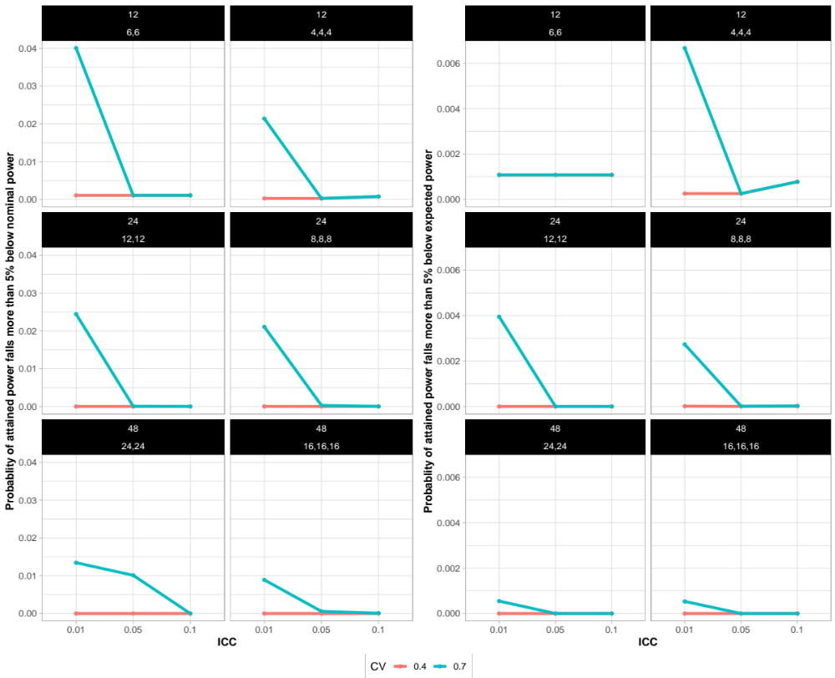

Figure A3.2 The probability that the attained power falls more than five percent below the nominal (left set of panels) or the expected (right set of panels) power by CV. The risks increased as CV increased in all scenarios except the ones with 12 clusters. The risks were near zero when the CV was smaller than 0.7, except for the scenarios with 12 clusters and two size groups. Panel labels identify the total number of clusters (first line) and the distribution of clusters to the cluster size groups S:L or S:M:L (second line).
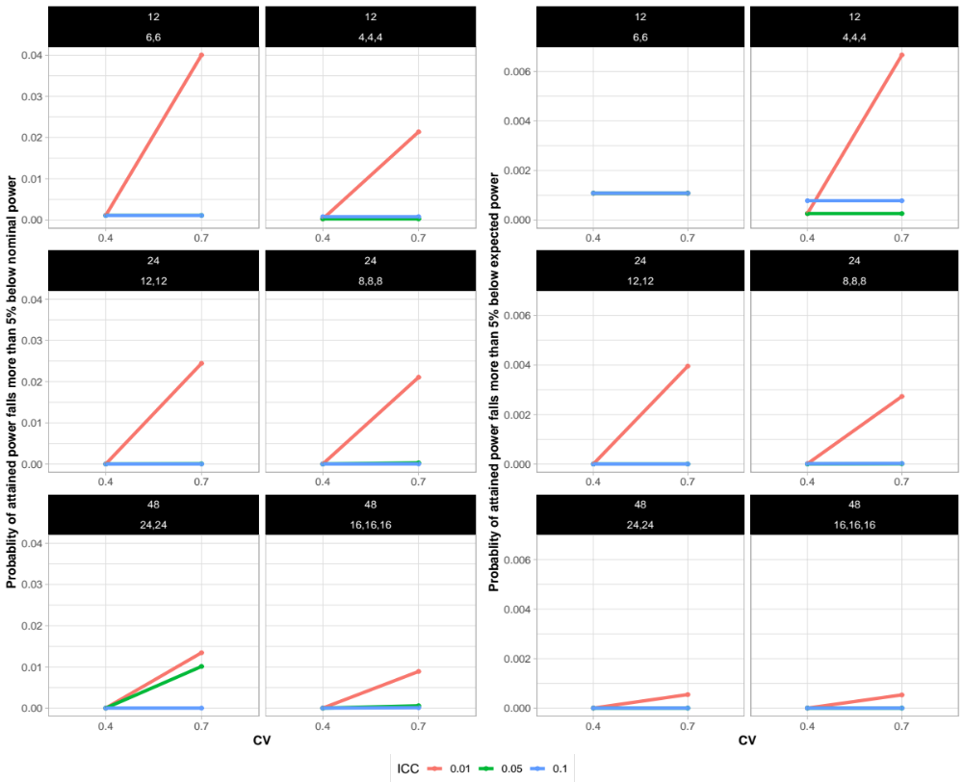

Figure A3.3 The relationship between treatment-vs-time period correlation and attained power among completed scenarios (A) and sampled scenarios (B). The attained power decreases considerably as the treatment-vs-time period correlation increases.

Figure A3.4 The relationship between treatment group imbalance and attained powers among completed scenarios (A) and sampled scenarios (B). A triangle pattern was observed in most scenarios. Large treatment group imbalances appeared to be associated with higher power.

Figure A3.5 Side-by-side boxplots (upper panel) comparing the power distributions between evaluated and predicted attained powers for the sampled scenarios. For each scenario, the close overlap in the boxplots suggest that the evaluated results provide a reliable estimate for the entire set of allocations. The risks of the attained power falling more than five percent below the expected power on both evaluated and predicted distribution among sampled scenarios (lower panel) were very similar within each scenario.
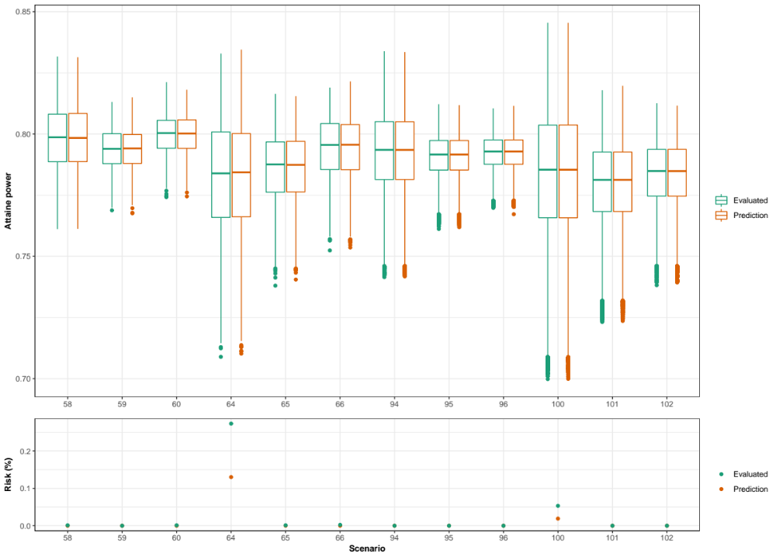

A.4 Prediction errors using the predictive model among completed scenarios
Table A.4 Prediction error for completed scenarios
Case | Max absolute residual error | RMSE | Average residual error
1 | 0.004 | 0.003 | 0.002
2 | 0.006 | 0.003 | 0.002
3 | 0.007 | 0.005 | 0.003
4 | 0.007 | 0.003 | 0.002
5 | 0.007 | 0.004 | 0.003
6 | 0.006 | 0.003 | 0.002
7 | 0.006 | 0.003 | 0.002
8 | 0.003 | 0.002 | 0.001
9 | 0.007 | 0.004 | 0.002
10 | 0.008 | 0.003 | 0.002
11 | 0.008 | 0.004 | 0.002
12 | 0.006 | 0.003 | 0.002
13 | 0.007 | 0.003 | 0.002
14 | 0.005 | 0.004 | 0.002
15 | 0.006 | 0.004 | 0.003
16 | 0.007 | 0.004 | 0.003
17 | 0.007 | 0.005 | 0.003
18 | 0.011 | 0.005 | 0.003
19 | 0.007 | 0.003 | 0.002
20 | 0.01 | 0.004 | 0.003
21 | 0.012 | 0.004 | 0.003
22 | 0.009 | 0.003 | 0.002
23 | 0.011 | 0.003 | 0.002
24 | 0.011 | 0.004 | 0.003
25 | 0.009 | 0.003 | 0.002
26 | 0.009 | 0.003 | 0.002
27 | 0.008 | 0.003 | 0.002
28 | 0.011 | 0.003 | 0.003
29 | 0.015 | 0.004 | 0.003
30 | 0.01 | 0.004 | 0.003
31 | 0.018 | 0.006 | 0.005
32 | 0.008 | 0.003 | 0.003
33 | 0.012 | 0.004 | 0.003
34 | 0.015 | 0.005 | 0.004
35 | 0.013 | 0.004 | 0.003
36 | 0.009 | 0.003 | 0.002
37 | 0.005 | 0.002 | 0.002
38 | 0.006 | 0.002 | 0.002
39 | 0.005 | 0.003 | 0.002
40 | 0.008 | 0.002 | 0.002
41 | 0.009 | 0.003 | 0.002
42 | 0.008 | 0.003 | 0.002
43 | 0.006 | 0.002 | 0.002
44 | 0.008 | 0.003 | 0.002
45 | 0.006 | 0.002 | 0.002
46 | 0.009 | 0.003 | 0.002
47 | 0.006 | 0.002 | 0.002
48 | 0.008 | 0.003 | 0.002
49 | 0.008 | 0.002 | 0.002
50 | 0.009 | 0.003 | 0.002
51 | 0.008 | 0.003 | 0.002
52 | 0.01 | 0.004 | 0.003
53 | 0.012 | 0.004 | 0.003
54 | 0.009 | 0.004 | 0.003
73 | 0.006 | 0.002 | 0.002
74 | 0.008 | 0.003 | 0.002
75 | 0.009 | 0.003 | 0.002
76 | 0.011 | 0.003 | 0.002
77 | 0.008 | 0.002 | 0.002
78 | 0.008 | 0.002 | 0.002
79 | 0.009 | 0.002 | 0.002
80 | 0.01 | 0.003 | 0.002
81 | 0.009 | 0.003 | 0.002
82 | 0.009 | 0.003 | 0.002
83 | 0.009 | 0.003 | 0.002
84 | 0.01 | 0.003 | 0.002
85 | 0.011 | 0.003 | 0.002
86 | 0.007 | 0.003 | 0.002
87 | 0.011 | 0.004 | 0.003
88 | 0.019 | 0.005 | 0.004
89 | 0.01 | 0.004 | 0.003
90 | 0.011 | 0.003 | 0.003

